**SAVEETHA SCHOOL OF ENGINEERING**

**SAVEETHA INSTITUTE OF MEDICAL AND TECHNICAL SCIENCES**

**INSTITUTE OF PLACEMENT AND TRAINING**

**CSA0987 –JAVA PROGRAMMING**

**NAME :** D.Harshavardhan chowdary

**REG.NO : 192372030**

**ASSIGNMENT:4**

1. Find the LCM and GCD of n numbers?

Sample Input:

N value = 2

Number 1 = 16

Number 2 = 20

Sample Output:

LCM = 80

GCD = 4

Test cases:

1. N = 3, {12, 25, 30}
2. N = 2, {52, 25, 63}
3. N = 3, {17, 19, 11}
4. N = -2, {52, 60}
5. N = 2, {30, 45}

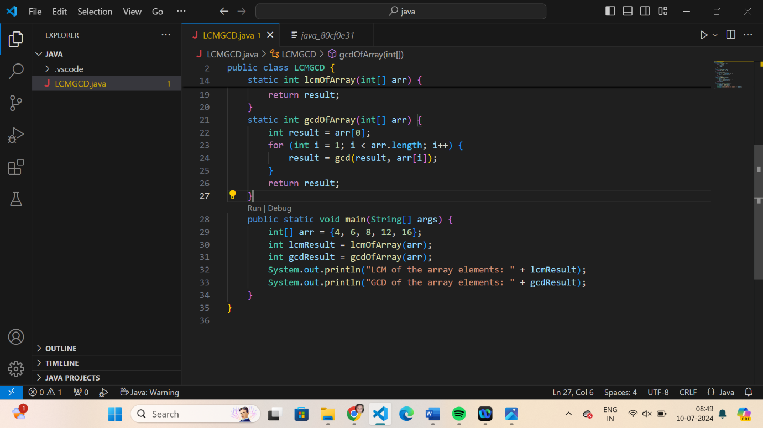

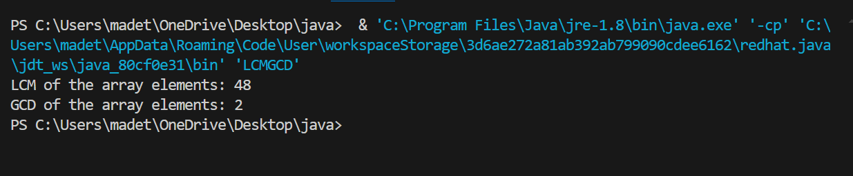

1. Write a program using function to calculate the simple interest. Suppose the customer is a senior citizen. He is being offered 12 percent rate of interest; for all other customers, the ROI is 10 percent.

Sample Input:

Enter the principal amount: 200000

Enter the no of years: 3

Is customer senior citizen (y/n): n

Sample Output:

Interest: 60000

Test Cases:

1. Principal: 2000 , Years: 0
2. Principal: 20000 , Years: -2
3. Principal: -2000 , Years: 2
4. Principal: 2 , Years: 2000
5. Principal: 0 , Years: 5

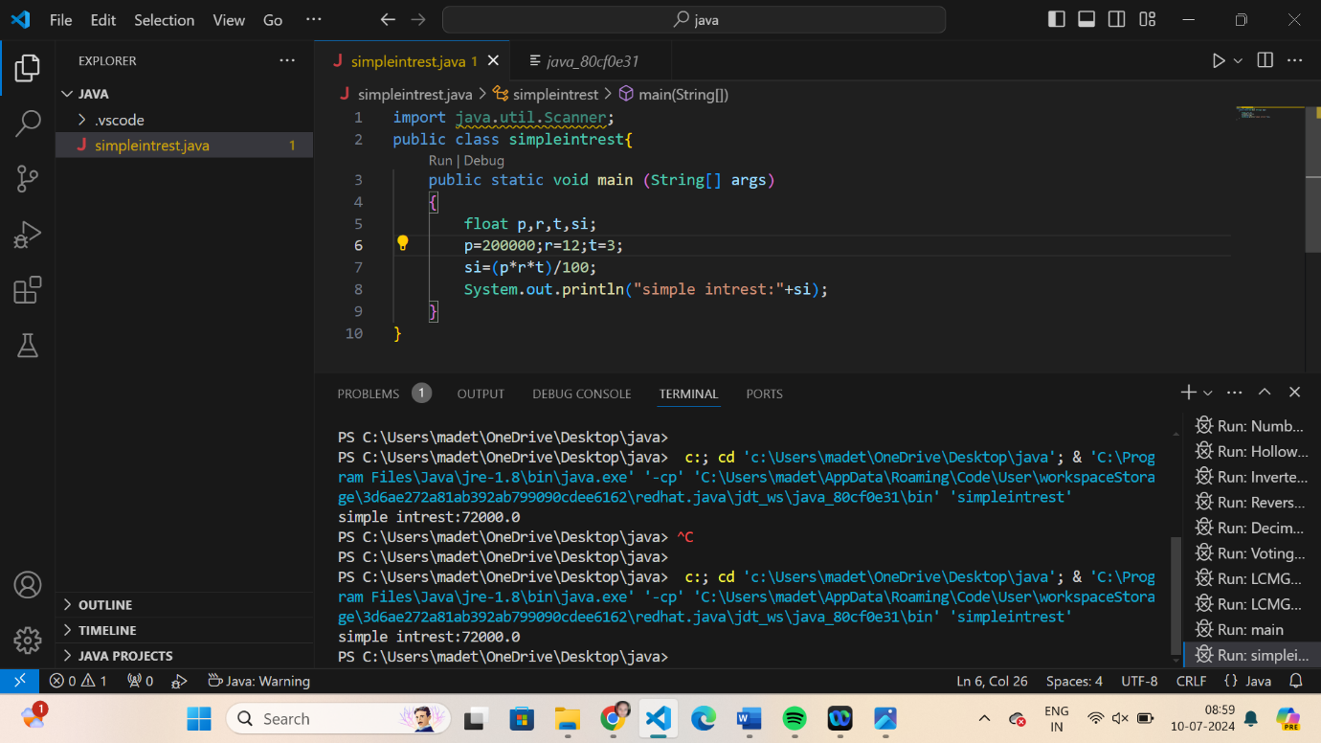

1. Write a program to print the Fibonacci series.

Sample Input:

Enter the n value: 6

**Sample Output:**

0 1 1 2 3 5

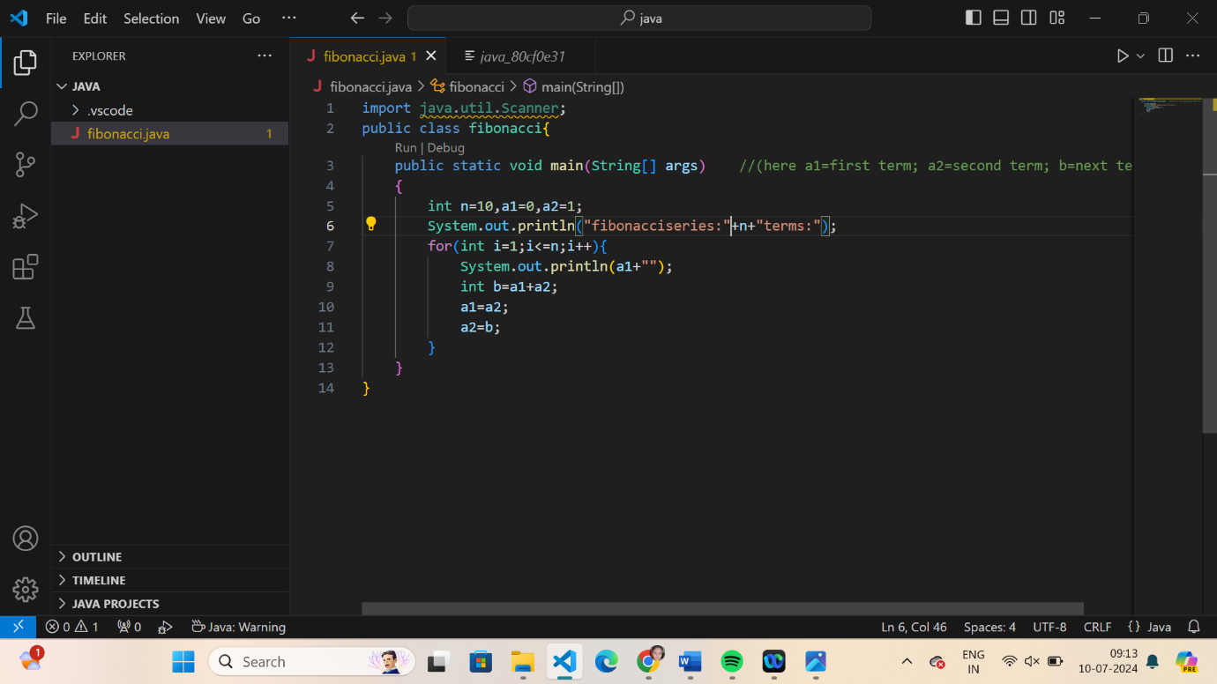

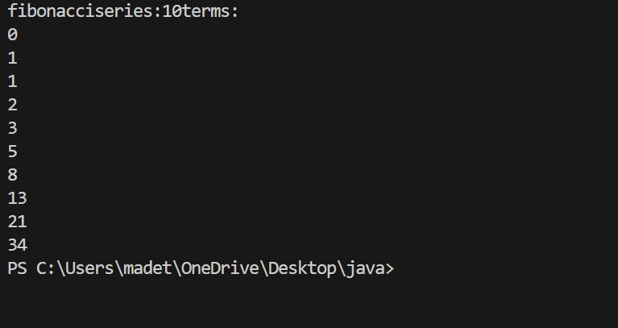

[Java Program to Find Even Sum of Fibonacci Series Till number N](https://www.geeksforgeeks.org/java-program-to-find-sum-of-fibonacci-series-numbers-of-first-n-even-indexes/)?

Sample Input: n = 4

Sample Output: 33

(N = 4, So here the fibonacci series will be produced from 0th term till 8th term:0, 1, 1, 2, 3, 5, 8, 13, 21

Sum of numbers at even indexes = 0 + 1 + 3 + 8 + 21 = 33)

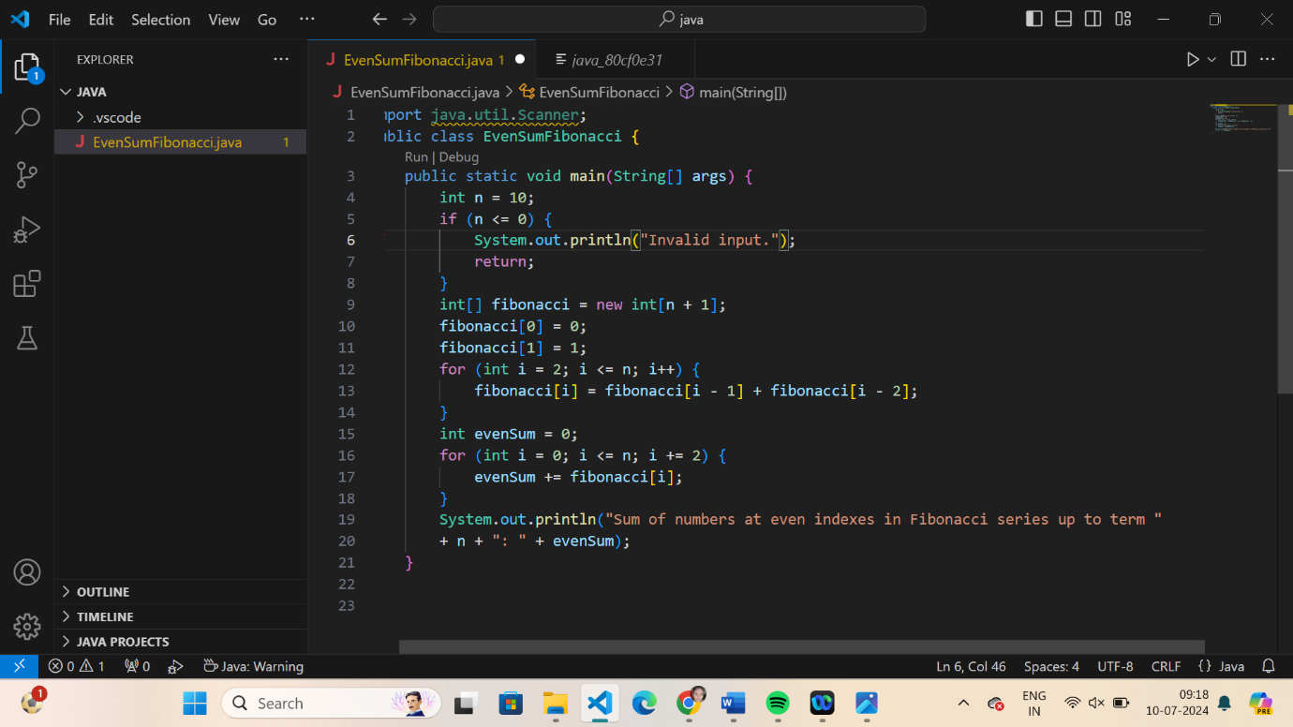

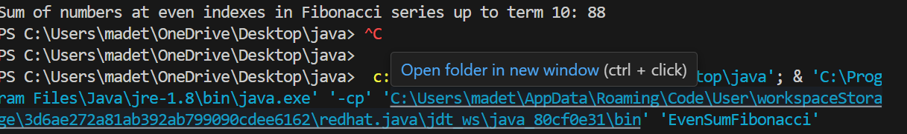

1. Write a program to print the numbers from M to N by skipping K numbers in between?

Sample Input:

M = 50

N = 100

K = 7

Sample Output:

50, 58, 66, 74, …..

Test cases:

1. M = 15, N = 05, K = 02
2. .M = 25, N = 50, K = 04
3. M = 15, N = 100, K = -02
4. M = 0 , N = 0 , K = 2
5. M = 200 , N = 200 , K = 5
6. Write a program to print all the composite numbers between a and b?

Sample Input:

A = 12

B = 19

Sample Output

14, 15, 16, 18

Test cases:

1. A = 11, B = 11
2. A = 20, B = 10
3. A = 0, B = 0
4. A = -5, B = 5
5. A = 7, B = -12

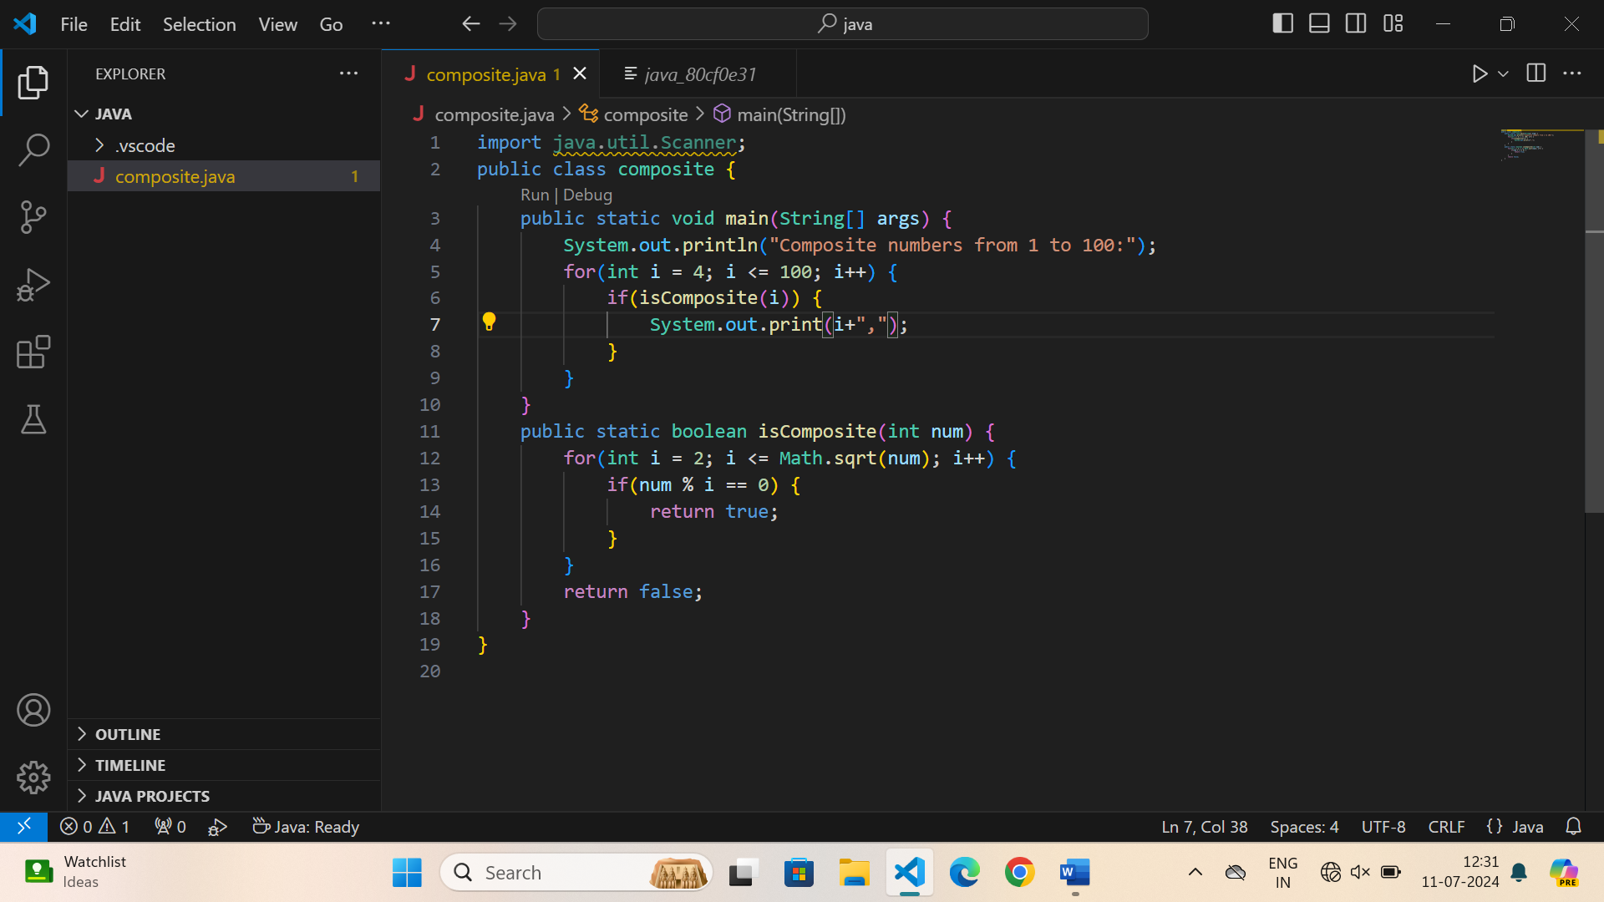

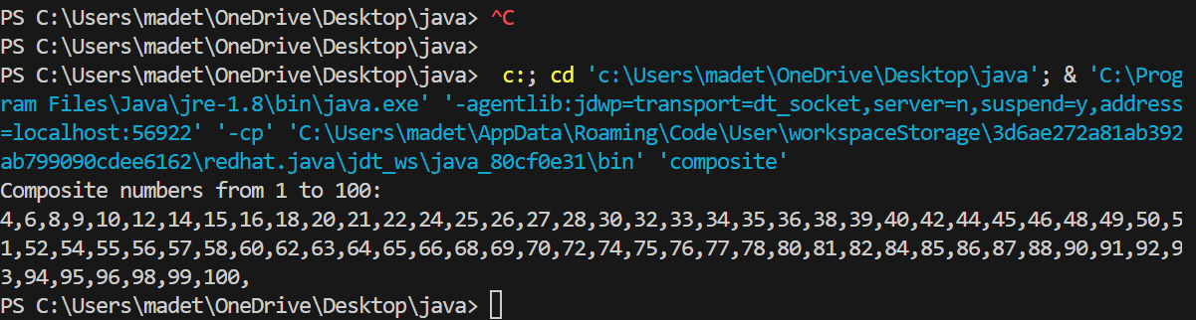

1. Find the factorial of n?

Sample Input:

N = 4

Sample Output:

4 Factorial = 24

Test cases:

1. N = 0
2. N = -5
3. N = 1
4. N = Q
5. N = 3A

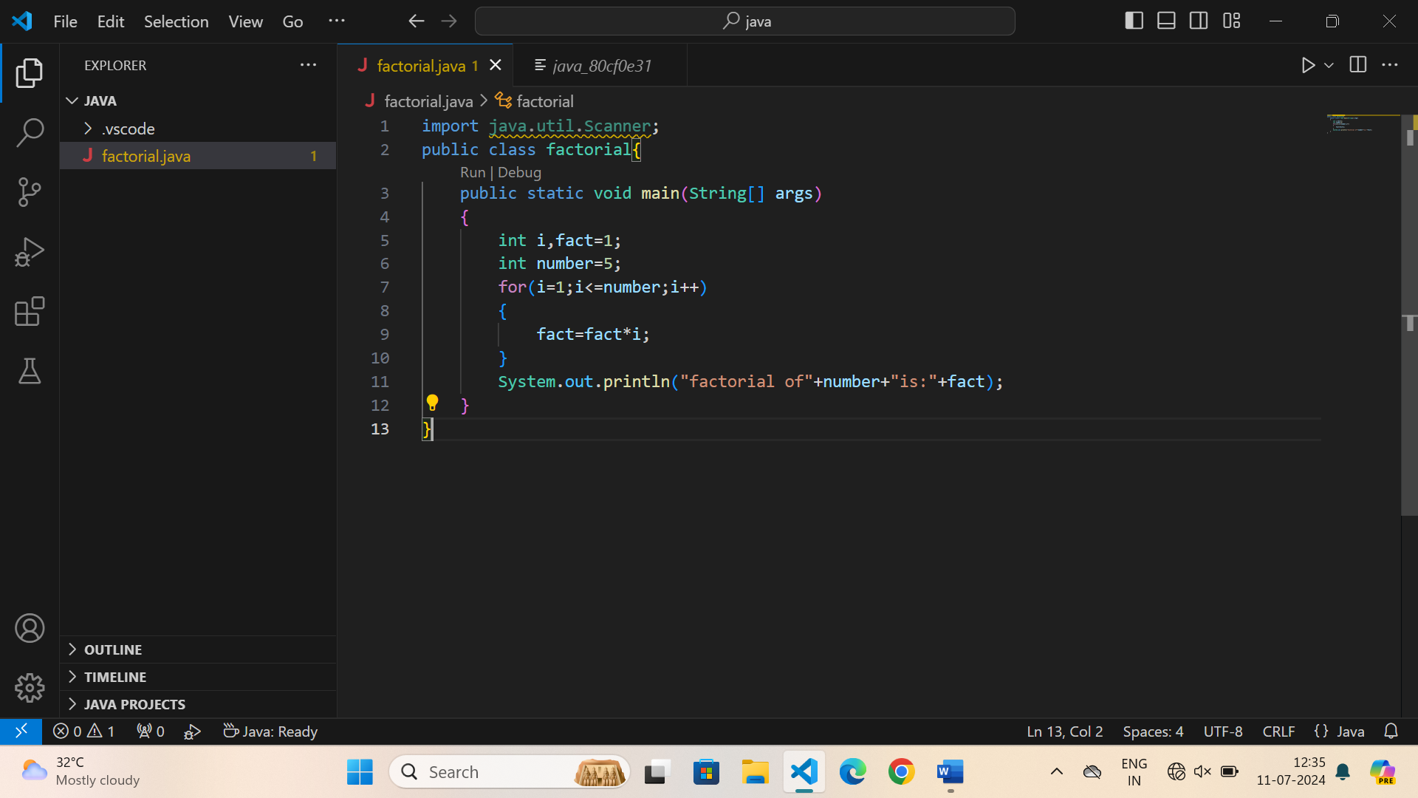

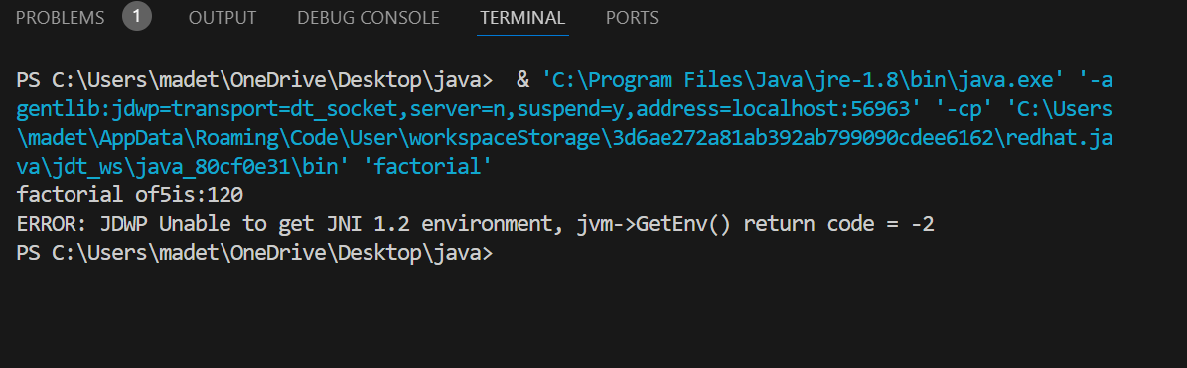

1. Find the year of the given date is leap year or not

Sample Input:

Enter Date: 04/11/1947

Sample Output:

Given year is Non Leap Year

Test cases:

1. 04/11/19.47
2. 11/15/1936
3. 31/45/1996
4. 64/09/1947
5. 00/00/2000

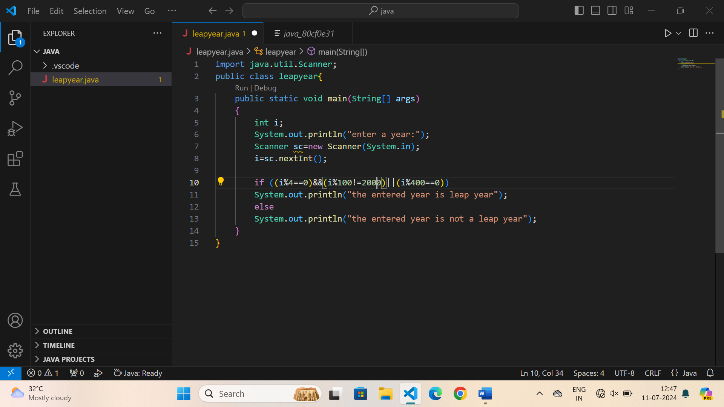

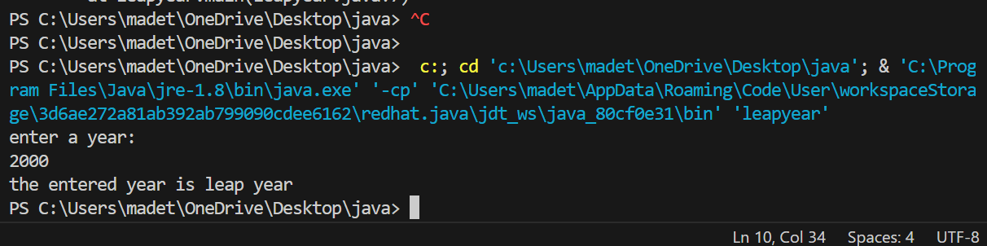

1. Find the number of factors for the given number

Sample Input:

Given number: 100

Sample Output:

Number of factors = 9

Test cases:

1. 343
2. 1080
3. -243
4. 101010
5. 0

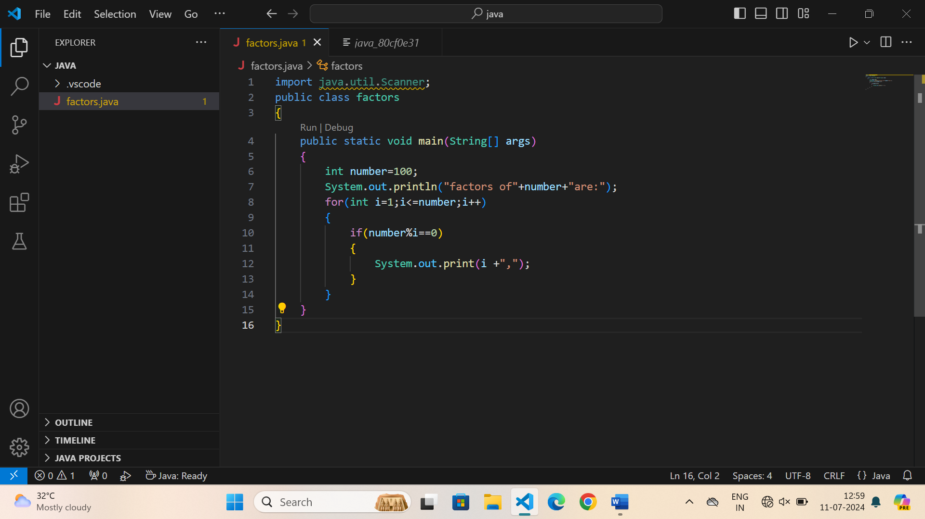

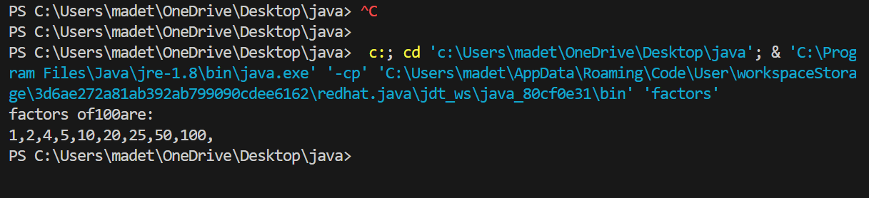

1. Write a program to print the given number is Perfect number or not?

Sample Input:

Given Number: 6

Sample Output:

It’s a Perfect Number

Test cases:

1. 17
2. 26!
3. 143
4. 84.1
5. -963

